Parameter estimation in fishery models
Table of Contents
Introduction 1
Simulation 1
Base model 1
Model with one covariate 5
Data Cloning 7
Profile Likelihoods 8
Significance 8
References 9

Introduction
Fish population dynamics models have been used for several decades to describe the relationship between spawner abundance and future recruitment. The parameters in these models are estimated and used to predict the population size in the future, to manage fisheries, and more recently to understand factors (physical, biological, or human) that cause changes in fish populations. However, the parameters in these complex models may not be uniquely identifiable. We used simulations, profile likelihood, and Bayesian hierarchical modelling to check the limitations of commonly used fisheries models, such as the Ricker and the Beverton-Holt model. We provide some guidelines on the most appropriate use cases for these models.

Simulation
We simulated the population dynamics of salmon using two spawner recruit models - Ricker and Beverton-Holt. The simulation models contained submodels for recruitment, harvest and age-structure, with natural variability in recruitment, harvest, and age-at-maturity.

Base model

Beverton-Holt Model
$$ln\left(\frac{R}{S}\right)=e^{α}-ln\left(1+\frac{e^{α}S}{R_{k}}\right)+ϵ$$
$$R_{K}=\frac{K}{e^{α}-1}$$
$$S_{MSY}=\frac{K}{e^{\frac{α}{2}}+1}$$
$$ϵ∼N\left(0,σ\right)$$

Ricker Model
$$ln\left(\frac{R}{S}\right)=α-\frac{S}{S_{max}}+ϵ$$
$$S_{max}=\frac{K}{α}$$
$$S_{MSY}=\left(1-W_{0}\left(e^{1-α}\right)\right)S_{max}$$
$$ϵ∼N\left(0,σ\right)$$
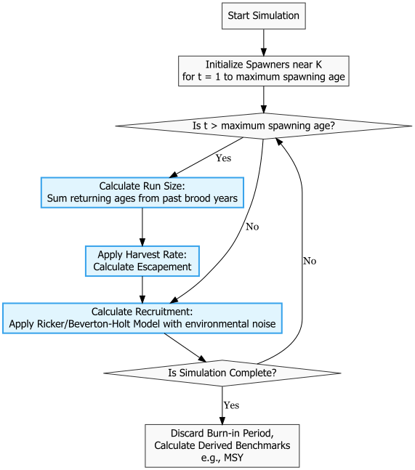
We simulated 100 different datasets and fit both the Ricker model and the Beverton-Holt model to these datasets. We then estimated the parameters and compared them to the true values.
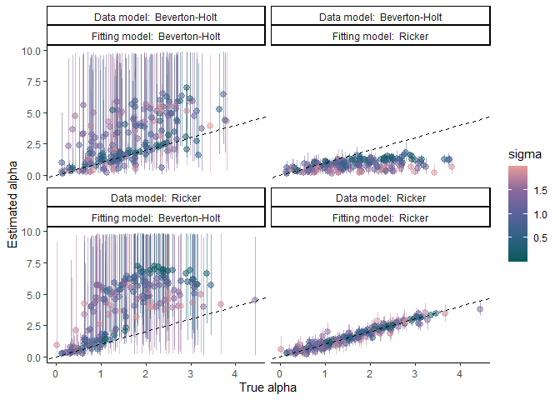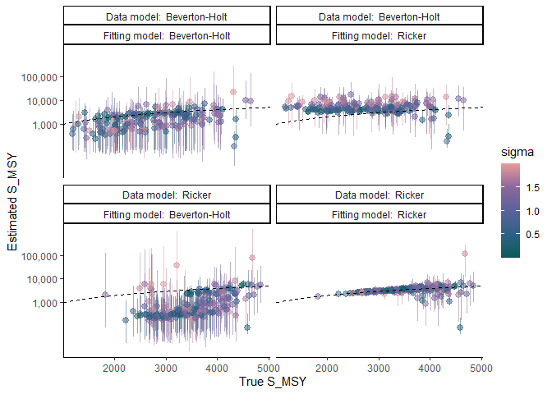
We then simulated 1 dataset with the same parameter values and fit the Ricker model and the Beverton-Holt model 1000 times. We then plotted the estimated median of the alpha parameter.
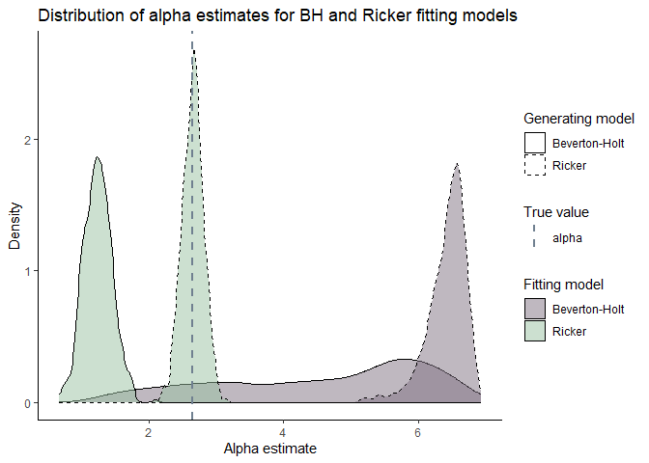
In addition to simulating data from the base model, we simulated data with covariates: 1) Sea-surface temperature (SST), 2) Forestry.

Model with one covariate

SST
We used Extended Reconstructed Sea-Surface Temperature from the NOAA website from 1925 to 2025.

Beverton-Holt Model
$$ln\left(\frac{R}{S}\right)=e^{α}-ln\left(1+\frac{e^{α}S}{R_{k}}\right)+βSST+ϵ$$
$$R_{K}=\frac{K}{e^{α}-1}$$
$$ϵ∼N\left(0,σ\right)$$

Ricker Model
$$ln\left(\frac{R}{S}\right)=α-\frac{S}{S_{max}}+βSST+ϵ$$
$$S_{max}=\frac{K}{α}$$
$$ϵ∼N\left(0,σ\right)$$
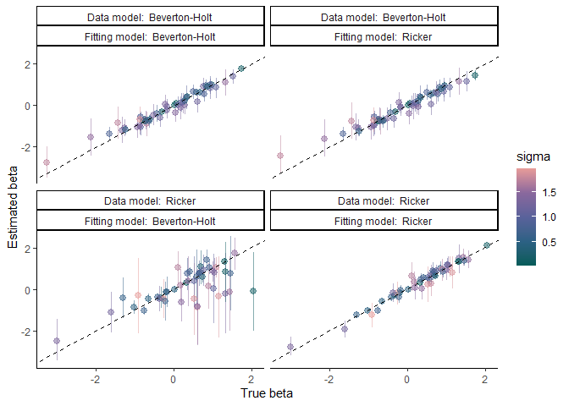

Forestry
For the forestry data, we used the cumulative disturbed area in the Carnation Creek watershed as the covariate. This is a monotonically increasing covariate.

Beverton-Holt Model
$$ln\left(\frac{R}{S}\right)=e^{α}-ln\left(1+\frac{e^{α}S}{R_{k}}\right)+βForestry+ϵ$$
$$R_{K}=\frac{K}{e^{α}-1}$$
$$ϵ∼N\left(0,σ\right)$$

Ricker Model
$$ln\left(\frac{R}{S}\right)=α-\frac{S}{S_{max}}+βForestry+ϵ$$
$$S_{max}=\frac{K}{α}$$
$$ϵ∼N\left(0,σ\right)$$
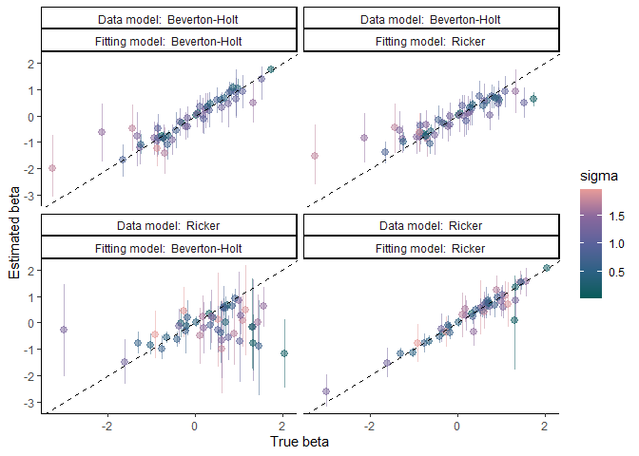

Data Cloning
To test parameter estimability using data cloning, we cloned the data $k$ times, we then fit the Ricker model and the Beverton-Holt model in a Bayesian framework to this dataset. We plotted the posterior variance of the alpha parameter to evaluate the rate of shrinkage of the posterior variance. If the parameter is non-estimable or practically inestimable, the posterior variance will not shrink towards 0 [1].
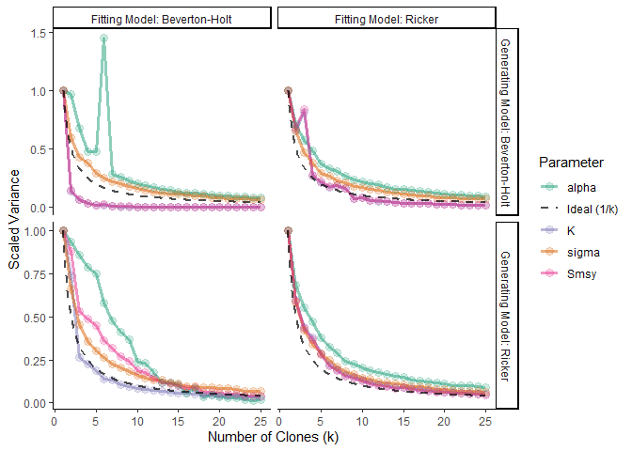

Profile Likelihoods
Profile likelihood is a statistical tool that can be used to determine whether a parameter is identifiable, practically unidentifiable, or structurally unidentifiable [2]. We plot the profile likelihood of $α$, and $K$ parameters of both the Ricker model and the Beverton-Holt model after fitting these models to data generated from both the Beverton-Holt equation and the Ricker equation.

Significance
The Beverton-Holt model and the Ricker model differ in their assumptions about density-dependence at high spawner levels. The structural differences in the two models lead to variation in parameter estimation. The Beverton-Holt model usually overestimates $α$ and carrying capacity while the Ricker model usually underestimates them [3]. While the Beverton-Holt model is usually a better statistical fit, the Ricker model is usually recommended because it is less sensitive to the priors and as a precautionary option to avoid over harvesting [4]. A failure to represent population dynamics accurately can result in endangering populations by overharvesting and also loss of credibility in the modelling process.
Using a Bayesian approach allows us to quantify the full uncertainty associated with all parameters and metrics of interest, such as harvest targets. However, having high levels of uncetainty are unhelpful with management decisions. It is useful to know when the model structure leads to high levels of uncertainty in the parameters and metrics of interest. We can then use this information to make informed decisions about which model to use for specific datasets and to be cautious about the interpretation of the results.

References
1. Peacock SJ, Krkošek M, Lewis MA, Lele S. Study design and parameter estimability for spatial and temporal ecological models. Ecology and Evolution. 2017;7: 762–770. doi:10.1002/ece3.2618
2. Raue A, Kreutz C, Maiwald T, Bachmann J, Schilling M, Klingmüller U, et al. Structural and practical identifiability analysis of partially observed dynamical models by exploiting the profile likelihood. Bioinformatics. 2009;25: 1923–1929. doi:10.1093/bioinformatics/btp358
3. Zhou S. Discriminating alternative stock–recruitment models and evaluating uncertainty in model structure. Fisheries Research. 2007;86: 268–279. doi:10.1016/j.fishres.2007.06.026
4. Godbout L, Fu C, Irvine JR. Evaluation of chum salmon fishery performance using ricker and beverton–holt stock recruitment approaches in a bayesian framework.

